Language Acquisition Processing Lab

Director: Dr. Karin Stromswold

Supervisor: Ana Rinzler

Version: June 11th 2018   
Topic: Getting info from Praat/Praat Scripting

**Overview**

There is a praat script (i.e. praat code) that gathers all of the necessary duration information between the marked boundaries, as well as other information such as intensity and formant info. Luckily, if you want to use this script, there is only one thing you need to change to make it work for you files!

**Here are the following steps:**

1. Download the script from the “practice slice” folder on Github. Then open your individual practice slice folder and it will be there. It is also on the lalp google drive title “scriptKatieAllTiersdebugged,praat”.
2. Open Praat
3. Make sure your .wav files, textgrids files, and the praat script are all in the same folder
4. Make sure that the file names of your .wav files and textgrids files are identical! This is very important because the script will not work if the name is not exactly the same
5. Change the directory in the script to match the directory of the files in your computer (there are instructions on how to do this in the script)

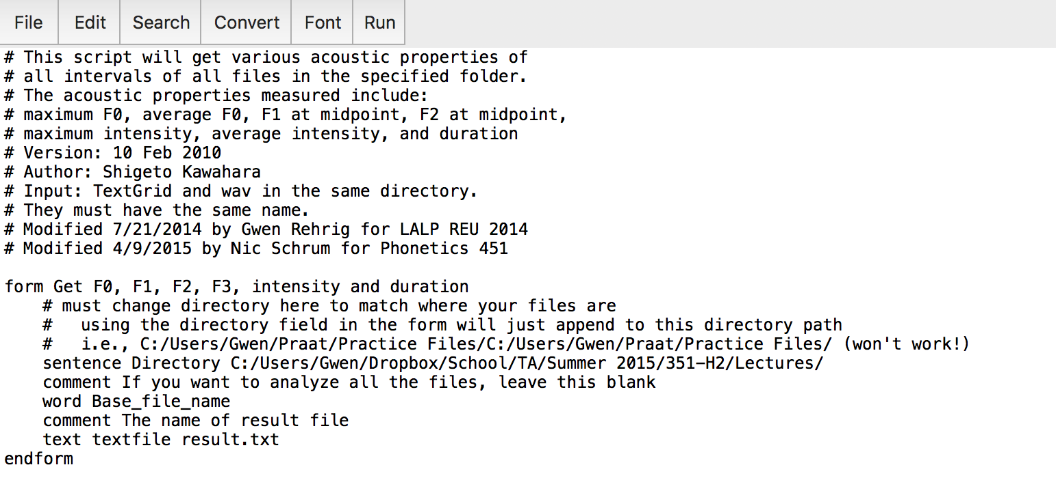

*The box outlined in red above is the directory path you want to change.*

*Click on the Run button outlined in green after changing directory*

1. After you change the directory to match the directory of the files on your computer, hit the RUN button 🡪 then click on RUN (*not* run selection). The screen below will pop up. Make sure to rename the “result.txt” to something meaningful!

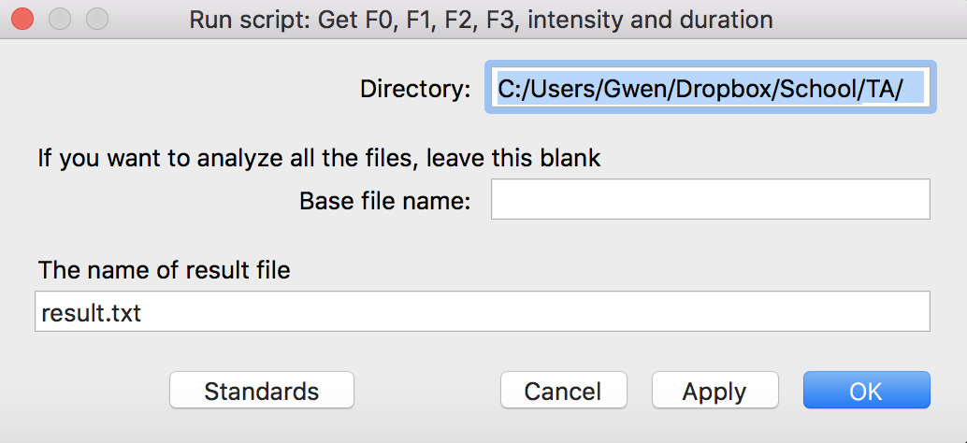

🡨 This should match you directory

1. After you run it, if there are no problems, the result.txt file will appear in the same file where your .wav, textgrids and praat script exist.